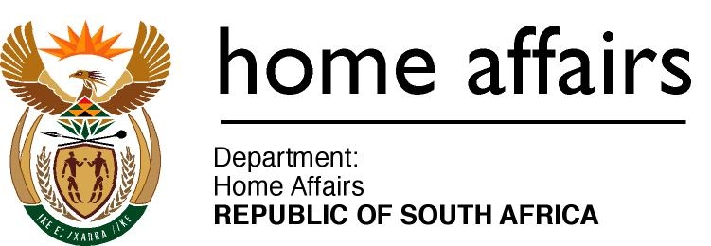

**NATIONALITY DAYS FOR ASYLUM SEEKERS AT REFUEE RECEPTION CENTRES**

**Updated: 1 May 2022**

|  |  |  |
| --- | --- | --- |
| **DAY** | **COUNTRY** | **LANGUAGE** |
| **Monday** | SADC, North Africa & Asians - Angola , Botswana, DRC, Tanzania, Lesotho, Madagascar, Malawi, Mauritius, Mozambique, Namibia, Seychelles, Zimbabwe, Swaziland, Egypt, Algeria, Pakistan, India and China | French, Swahili, Lingala, Tshiluba, Shona, Chichewa, Portuguese, Arabic, Bangali, Urdu, Gujarat, Punjabi, Hindi, Tsonga |
| **Tuesday:** | SADC, North Africa & Asians - Angola , Botswana, DRC, Lesotho, Madagascar, Malawi, Mauritius, Mozambique, Namibia, Seychelles, Zimbabwe, Swaziland, Egypt, Algeria, Pakistan, India and China | French, Swahili, Lingala, Tshiluba, Chichewa, Portuguese, Arabic, Bangali, Urdu, Gujarat, Punjabi, Hindi, Ndebele |
| **Wednesday** | Ethiopia, Burundi, Rwanda, Uganda, Eritrea and Kenya | Amharic, Hadiya, Kambati,  Oromo, Swahili, French, Kirundi  Kinyarwanda, Tigrinya, Luganda  Kirundi |
| **Thursday** | Somalia, Cameroon, Senegal, Eritrea and Ethiopia, Ghana and  Burundi | French, Wolof, Swahili  Lingala, Twi, Somalia, Amharic,  Hadiya, Oromo, Triginya, Kambata, Kirundi |
| **Friday -** | **ENGLISH DAY plus:** Somalia, Senegal, China and French, Swahili and Lingala speakers, | French, Swahili, Lingala, Mandarin (China), Somalia, Wolof, |